How the PPCR is Supporting Improvements in Hydrometeorological Monitoring

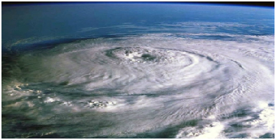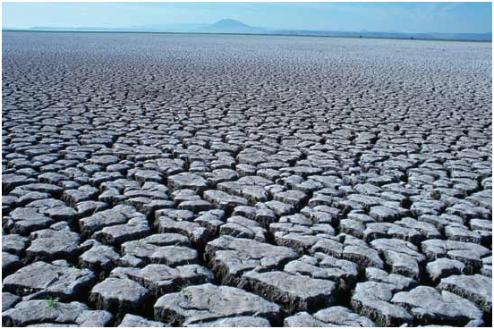
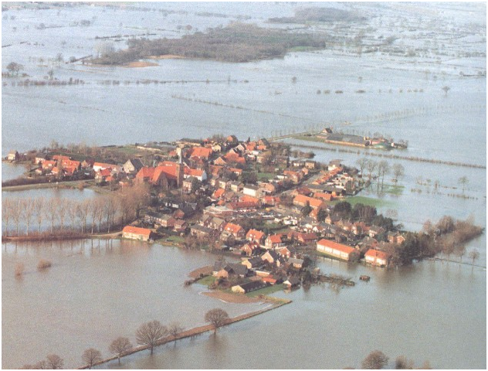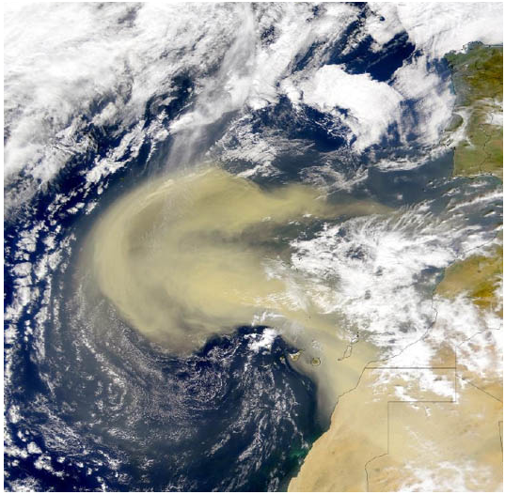

September 9, 2011

PPCR Thematic Note 1

General objective
This Note provides information on why hydromet service provision and improvement is of relevance to countries seeking climate-resilient growth and how the Pilot Program on Climate Resilience (PPCR) is addressing this need. It contains information on the types of extreme climate that is faced in various PPCR countries, the current institutional gaps regarding hydrometeorological services, and major categories as well as specific types of investments being undertaken, along with funding information.
This overview is based on information in the Strategic Programs for Climate Resilience (SPCRs) and Project Concept Notes (PCNs) for Bangladesh, Cambodia, Mozambique, Nepal, Niger, Tajikistan, Zambia, and the Pacific (Samoa) and Caribbean Regional programs (Grenada, St. Vincent and the Grenadines).

Hydrometeorological services & development
Many PPCR countries are highly vulnerable to current extremes in climate, such as floods, droughts and storms, which often result in loss of life, property and livelihoods for many. For example, in Bangladesh alone, storms and floods have resulted in the deaths of 482,566 people and economic losses of $15,823,700, since 1970. In many regions, climatic extremes are expected to become more frequent and/or intense with climate change. In order to be better prepared for severe weather events and also for changes in climatic norms, many PPCR countries have identified improvements to hydrometeorological data and networks as a priority need. Assistance in this area may include a broad range of activities, such as: improvements to remote sensing equipment, expansion of river basin monitoring capabilities, training in use of relevant software, improved in-country climate modeling abilities, and establishment of early flood warning systems.
Why countries need good hydrometeorological data
Establishing a baseline: Since climate may differ widely over various regions in a country, comprehensive spatial coverage of hydromet observation data is important. Many PPCR countries, however – e.g., Niger and Yemen – do not have good spatial coverage of weather monitoring stations, resulting in an array of unknowns regarding baseline climate in these areas.
Understanding current climate better: Without having a thorough understanding of current climate through accurate records of long-term temperature and rainfall trends, it is difficult to tell whether and how climate is changing, or to validate the results of climate models. Thus, investments in monitoring stations and equipment, databases, and information-sharing are very much needed.
Essential inputs to early warning systems: With large segments of PPCR country populations vulnerable to severe storms, floods and drought, establishing early warning systems is a crucial element in reducing losses and averting disasters when natural hazards strike. However, early warning systems often require reliable meteorological and hydrological data inputs.
Better ability to adapt: Countries that are better able to understand current and potential future climate, particularly on finer spatial scales, are better able to understand how their populations may be vulnerable, and to tailor their adaptation responses better.

Improved social protection: Weather based index insurance relies on the availability good local scale climate data. In its absence, communities struck by extreme climate events may not have access to such insurance schemes. Also, both communities and insurance companies that have access to good climate information, including forecasts, are better able to prepare for extreme climate and thus potentially avert disaster.
To inform development in key sectors: Climate-sensitive sectors can be developed in a more resilient manner if long-term, reliable, local climate data is readily available. Building codes and standards are also more easily adjusted when long-term local data exists.

Key issues
Moving towards a new generation of hydromet projects entails a broad set of issues and challenges that need to be met. Institutional capacity building, provision of hydromet equipment, and better linkages with the communities for improved risk communication have all been highlighted as important areas in the SPCRs. Securing sustained support for the programs is also likely to emerge as a concern.
An important ingredient for successful CIS programs – particularly with regard to early warning systems – is the determination of user needs and how to best communicate targeted information to users (e.g., communities) in a way that is most relevant for them. At present there is little emphasis on this aspect in the SPCRs, but it is an issue that will continue to be addressed with the country/project teams.

Table 1: Extreme climatic events in PPCR countries
Country | Extreme event
 | Inundation | Flash flooding/ heavy rainfall | Drought/dry periods | Hurricanes  /trop. cycl.* | GLOFs** | Sandstorms | Landslides | Locust invasions | Heatwaves
Bangladesh

Cambodia

Grenada

Mozambique

Nepal

Niger

Samoa

SVG

Tajikistan

Zambia

* Including storm surges.
** Glacial Lake Outburst Floods

Figure 1: Baseline conditions wrt hydrological monitoring, as reported by PPCR countries
BASELINE

SVG
Information is lacking in several areas.
MOZAMBIQUE
Fully operational integrated hydromet systems for Zambezi and Limpopo basins do not exist
SAMOA
Limited awareness of flood risks

GRENADA
Lack of coordination and systems for management of the information and data needed for natural hazard risk assessment and mitigation activities.
CAMBODIA
- Lack of accurate and reliable area-specific climate change relevant information.
- Most of Cambodia’s automatic weather stations have been dysfunctional the past few years
- Weather data from the national met stations is not reliable
- The number & type of hydrological monitoring sites are insufficient for effective early warning.
NIGER
- Low density of monitoring stations;
- Contradictory results of climate models for Niger make it difficult to undertake study of impacts and vulnerability of Niger to climate change;
- Implementation of the Global Observatory System (GOS) in Niger has experienced significant gaps and shortcomings in recent years especially by an important decline in financial resources;
- Need to upgrade the quality and accessibility of weather and climate information

NEPAL

- Limited real-time flood and drought information exist and currently do not reach vulnerable communities;
- Development of hydromet monitoring has been piecemeal

Table 2a: Types of activities to be undertaken through hydromet improvements
Country | Type of hydromet service improvement
 | Early warning systems | Improved equipment | Better observations | Improved forecasting | Improved climate change modeling | Capacity building and institutional improvements | Research (e.g., glaciology, water resources)
Cambodia

Grenada

Mozambique

Nepal

Niger

Samoa

SVG

Tajikistan

Zambia

Figure 2b: Country activities relating to Early Warning Systems
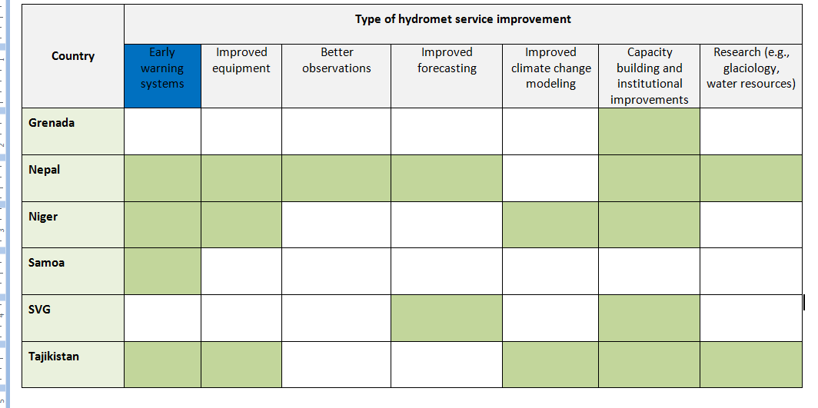

Country | Type of Early Warning System (EWS) activity
 | Warnings & alerts | Community-based EWS | Capacity building | Emergency response | User needs
Cambodia | Construction and upgrading of early warning systems; strengthen national capacity for flood and drought forecasting. | Some funds will be directed to establish community-based early warning systems, with special attention given to areas of importance for women, youth & indigenous communities | Increased capacity of relevant local government agencies on  flood and drought forecasting and early warning
Mozambique | Design of a fully integrated and comprehensive early warning system including flood monitoring and forecasting for Limpopo and Zambezi basins | Integrated capacity building program will ensure improvements in short-term (a few days) forecasts as well as longer-term climate change |  |  | Develop, design, procure, and install decision support tools
Nepal |  | Strengthen links to community based early warning systems for GLOFs | Support the early warning system operationalization at the community level through an ICT (information, communication, training) campaign
Design, develop, establish and test
community-based early warning systems in priority vulnerable communities
Niger | Establish an alert system for risks associated with climate change
Samoa | Assess adequacy of early warning systems | Install community early warning systems |  | Assess adequacy of safe havens for retreat during a disaster event
Tajikistan | Improve the national hydro-meteorological monitoring system to provide timely warnings on dangerous events, support water management, and build the evidentiary basis for climate variability and change |  |  | Bolstering the forecasting, warning, and response system for Emergency Situations
Zambia | Develop and apply EWS that combine scientific and indigenous knowledge. | At community level, appropriate ICT technology and crowdsourcing tools will be used to structure and georeference information to allow the various Platforms to carry out a deeper analysis of the problems, and elaborate appropriate responses to problems emerging from the field. 2-way communication. |  |  | Ensure dissemination of climate information (climate conditions, early warning, or specialized adaptation advice) through simplified language, easily understandable by different users.
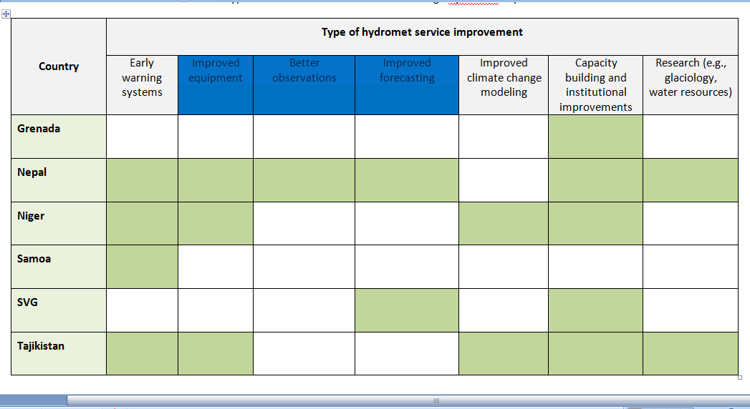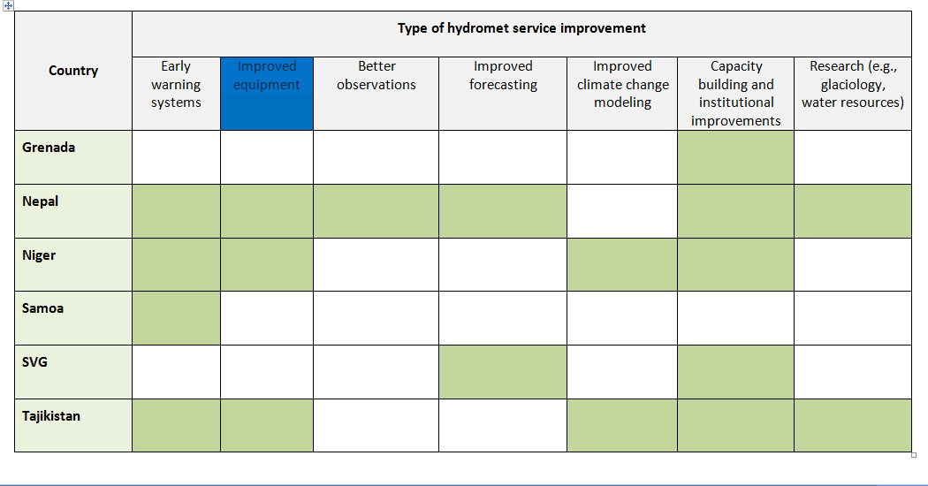
Figure 2c: Activities relating to improvements in hydromet equipment

Country | Type of hydromet equipment improvements
 | Observation and forecasting | Strengthening networks | ICT and data processing
Cambodia | Installation of hydro-meteorological monitoring facilities. | Improving hydromet data management networks
Mozambique |  | Procurement and installation of equipment and services for rehabilitation and modernization of hydrometric network; design and quantify the hydro-meteorological networks | Conduct an assessment of existing hydro-meteorological data; assess the efficiency and quality of data supplied from the present monitoring structures and of the equipment used for data collection and propose adequate models according to the characteristics of each region; improve processing and analysis of data; upgrading of the existing manually operated stations and database; define roles, functions, and coordination mechanisms between those institutions responsible for the collection of data
Nepal | Procure and install real-time hydro-meteorological monitoring equipment (e.g. rain gauges, snow pillows/gauges, water level gauges, discharge measurement equipment, mid-atmosphere weather radars for country-wide 3-day forecasting, automatic weather stations, lightning detectors and wind profilers etc.) and appropriate telemetry system
Niger |  | Strengthen the network of meteorological equipment | Strengthen technical services for the collection and processing of climatic data
SVG | Strengthen hydrometeorological monitoring and analysis;
 | Strengthen marine forecasting ability
Tajikistan | Major technical re-equipment of the observation networks |  | Strengthening of the information-technology base of the service
Zambia |  | Rehabilitation and upgrading of existing hydro-meteorological stations; installation of selected automated stations in the two sub-basins; upgrading of satellite receiving equipment and electronic links; selected purchase of satellite imagery and digital elevation models to support  climate information dissemination | Public-private partnership to support development of a mobile phone platform to disseminate climate information to famers about weather and prevailing market conditions.

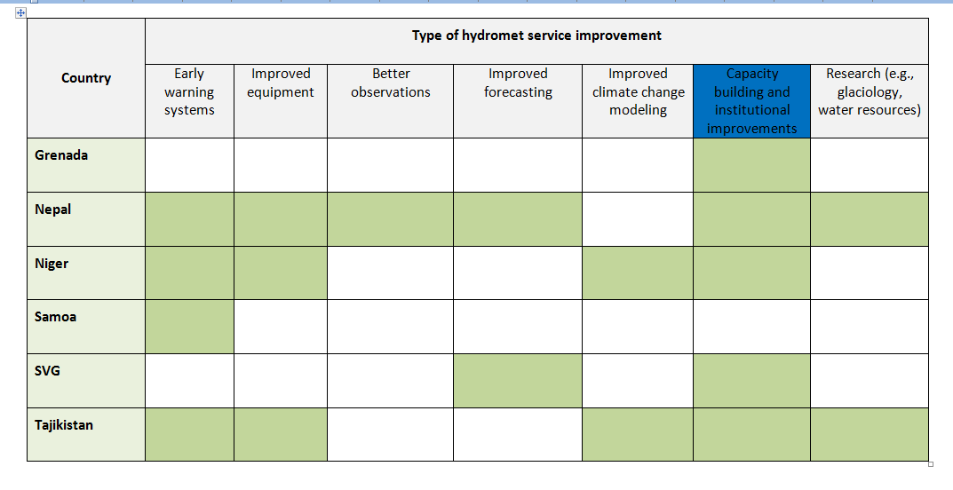
Figure 2d: Capacity building related activities relating to hydromet improvements

Country | Type of capacity building activity
 | Data collection, analysis & sharing | Capacity for V&A assmt | Institutional strengthening | Modeling
Cambodia |  |  | Strengthen national capacity for flood and drought forecasting& event mgmt.
Grenada | Provide training on Geographic Information Systems, GPS tools, information and database management, as well as provision of necessary goods for the establishment of the planning information system.
Mozambique |  |  | Economic valuation of hydromet information will guide agencies in deciding what investments to undertake to improve services | Improve modeling capacity for hydrology, weather, and climate; standardized training programs for staff on the design, installation, operation and maintenance for the water resources monitoring equipment, facilities and data acquisition methods, management information system and installed hydrological models; programs to increase technical capacities to process and interpret information from climate models
Nepal |  |  | Support capacity building to promote effective system use, including training, software and hardware, communication/networking systems
Niger | Strengthening the capacities of actors in the processing and analysis of climatic data, hydrological and meteorological data | Strengthening and increasing training for the assessment of vulnerability and adaptive capacity to climate variability and climate change in all sectors of development
SVG |  |  | Technical training and capacity building for Met Officers and Met officers; Capacity building of CSWA
Tajikistan |  |  | Institutional strengthening of the hydromet services | Establish dynamic downscaled modeling capacity within Hydromet;  Develop capacity to analyze and interpret output from climate models and science. This will include training of local experts (Hydromet, experts from academia, line ministries, NGOs, vulnerable communities) on climate impact modeling and applied risk management science
Zambia | Formulation of coherent policy for climate information sharing.

Table 3: Allocations (indicative) for Hydrometeorological Improvements
Country | Component | PPCR Partners |  | Funding (US$million)
 |  |  |  | PPCR funding* | PPCR requested |  | Co-financing
Cambodia | Promoting Climate-Resilient Water Resources and Related Infrastructure (Investment Component 1, Projects 1 & 2) | ADB |  | 19** |  |  | 63**
Mozambique | Investment Project 3: Climate-resilient water-enabled growth: transforming the hydro-meteorological services | WB |  |  | 10 |  | 5
Nepal | Building Resilience to Climate-Related Hazards (Investment Project 2) | WB |  | 41 |  |  | TBD
Niger | Improvement of Climate Forecasting Systems and Operationalization of Early Warning Systems | AfDB, IFC |  | 15 | 25 |  | 31.5
Tajikistan | - Improvement of Weather, Climate and Hydrological Service Delivery | WB |  | 7 |  |  | 7
 | - Climate Science and Modeling Program |  |  | 3 |  |  | TBD
Grenada | Disaster Vulnerability and Climate Risk Reduction Project (Investment Project 1; Component 2; sub-component 2.1) | WB |  | 15.2** | 15.55 |  | 10
 | Grenada Water Resources Assessment and Management Study (Technical Assistance 1) |  |  | 0.4 |  |  | 0.4
SVG | Acquisition and installation of telemetric hydro-climatic weather stations and software (Investment Project Component 2.1) | WB |  |  | 0.58 |  | TBD
 | Strengthening Met Office capacity (Component 3.3) |  |  |  | 0.225
 | Strengthening capacity of CSWA (Component 3.4) |  |  |  | 0.04
Samoa | Enhancing the Climate Resilience of Coastal Resources and Communities (KM component of Investment Project 2) | WB |  |  | 1.2
Zambia | Investment Project 1: Strengthening Climate Resilience in Zambia and the Barotse Sub-Basin (Component A2: Strengthened Climate Information) |  | 8 |  |  |  |  | 1.5
 | Investment Component 3: Private Sector Support to Climate Resilience. (Component 2: Climate Information and Dissemination Networks (weather, technical and market information to farmers) through Mobile Telecommunication Technology) | IFC | 1.8 |  |  |  |  | 4.5

*Often in the SPCRs, the cover sheet mentions the PPCR amount requested but the detailed project information section just refers to “PPCR funding” (so I’m not sure if that refers to received or requested).
**Figures not available for individual components/sub-components so total investment component or project cost is given.

EM-DAT: The OFDA/CRED International Disaster Database, www.emdat.be - Université Catholique de Louvain, Brussels, Belgium. http://www.emdat.be/result-country-profile

